**Topology**

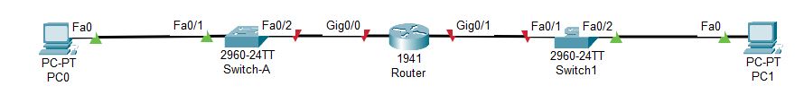

**Addressing Table**

|  |  |  |  |  |
| --- | --- | --- | --- | --- |
| Device | Interface | IP Address | Subnet mask | Default Gateway |
| Router | Gig0/0 | 192.168.17.1 | 255.255.255.0 | N/A |
| 2001:db8:3333:1::1/64 |  |
| fe80::1 |  |
| Gig0/1 | 192.168.18.1 | 255.255.255.0 | N/A |
| 2001:db8:3333::1/64 |  |
| fe80::1 |  |
| Switch-A | VLAN 1 | 192.168.17.5 | 255.255.255.0 | 192.168.17.1 |
| PC0 | NIC | 192.168.17.2 | 255.255.255.0 | 192.168.17.1 |
| 2001:db8:3333:1::2/64 |  | fe80::1 |
| PC1 | NIC | 192.168.18.2 | 255.255.255.0 | 192.168.18.1 |
| 2001:db8:3333::2/64 |  | fe80::1 |

**Step 1: Assign static IP information to the PC interfaces. (2 points)**

1. Configure the IPv4 and IPv6 addresses, subnet mask, and default gateway settings on PC-0. ***(with screenshot)***
2. Configure the IPv4 and IPv6 addresses, subnet mask, and default gateway settings on PC-1. ***(with screenshot)***

**Step 2: Configure the router. (5 points)**

1. Device name: **your name**, example: Azamat
2. Protect access to the console using the **console2021** password.
3. Protect access to the vty using the **vty2021** password.
4. Configure an enable password of **nauryz** and an enable secret password of **happynauryz**.
5. Create a banner that warns anyone accessing the device that unauthorized access is prohibited.
6. Encrypt all plain text passwords.
7. Configure the IPv4 and IPv6 addresses and activate both interfaces on the router.
8. Configure an interface description for each interface indicating which device is connected to it.
9. Save the configuration file to avoid loss if the switch is powered down.
10. Show startup configuration ***(with screenshot)***

**Step 3: Configure the Switch-A. (1 points)**

1. Assign a device name: **your surname**, example: Imanbayev.
2. Configure and activate the VLAN interface on the switch Switch-A.
3. Configure the default gateway for the switch Switch-A.
4. Save the running configuration to the startup configuration file.
5. Show startup configuration ***(with screenshot)***

**Step 4: Verify connectivity end-to-end connectivity.**

* 1. From PC-0, ping PC-1. ***(with screenshot)***
  2. From Switch-A, ping PC-1. ***(with screenshot)***

**You should upload this document with screenshots and packet tracer file.**